

NAME: ALI KAZMI
ID: F21604025

NIC INTERNSHIP COMPUTER ENGINEERING

CONTENTS OF THE REPORT

CHAPTER 1 INTRODUCTION OF INTERSHIP
CHAPTER 2 OVERVIEW OF THE ORGANIZATION
CHAPTER 3 WHAT I HAVE LEARNED
CHAPTER 4 REFFERENCE & CONCLUSION


CHAPTER 1
INTRODUCTION OF INTERSHIP

1.1 INTERNSHIP & ITS IMPORTANCE
Internships are structured programs designed to provide practical, real-world experience to individuals, often students, who are new to a specific field. These programs offer a bridge between academic learning and professional practice, making them a critical component in career development.

Key Benefits of Internships:

1. Real-World Experience: Internships allow individuals to apply theoretical knowledge in a practical setting, gaining hands-on experience that cannot be fully replicated in a classroom. This experience helps interns understand the day-to-day responsibilities and challenges in their chosen field.
2. Skill Development: Interns acquire both specialized and transferable skills. Specialized skills are specific to the field of internship, such as technical skills in engineering or marketing strategies in advertising. Transferable skills, like communication, teamwork, and computer proficiency, are applicable across various industries and enhance overall professional competence.
3. Resume Building: Participation in an internship significantly strengthens a resume. It provides tangible evidence of experience and skills, making candidates more attractive to future employers. This practical experience demonstrates a candidate's commitment to their field and readiness for professional challenges.
4. Career Exploration: Internships offer a valuable opportunity for individuals to explore different career paths within their field of interest. This exploration helps in making informed decisions about future career goals and specializations.
5. Networking Opportunities: Interns often have the chance to build professional relationships with industry professionals, mentors, and peers. These connections can be instrumental in finding job opportunities, gaining advice, and advancing in one's career.
6. Personal Growth: Beyond professional skills, internships foster personal development. Interns learn to navigate workplace dynamics, manage time effectively, and adapt to new environments, which contributes to their overall growth.

Internships for Various Individuals:

While internships are commonly associated with college students seeking initial exposure to their field, they are beneficial for a diverse range of individuals, including:
- Recent Graduates: To gain relevant experience and increase their employability.
- Career Changers: To acquire experience in a new field and make a transition smoother.
- Professionals Seeking Skill Enhancement: To stay updated with industry trends and acquire new competencies.

Objectives of Internships
Internships are designed to achieve several key objectives, providing a structured and valuable learning experience. Here are the major objectives:

1) Skill Development:
Objective: To provide students with the opportunity to develop specific skills related to their field of interest.
Description: Internships allow students to apply classroom knowledge in real-world situations, honing their technical and professional skills.

2) Work-Related Experience and Resume Building:
Objective: To assist students in gaining vital work experience and building a strong resume for a successful career.
Description: Practical experience gained through internships enhances a resume, making candidates more competitive in the job market.

3) Research Skills Development:
Objective: To develop research skills that are crucial for many professions.
Description: Interns often engage in research projects, learning to gather, analyze, and interpret data effectively.

4) Exposure to Profession or Industry:
Objective: To expose interns to a specific job, profession, or industry.
Description: Internships provide insight into the day-to-day responsibilities and work environment of a particular career path.

5) Business Skills Improvement:
Objective: To develop and improve business skills in areas such as communication, technology, quantitative reasoning, and teamwork.
Description: Interns refine their ability to work effectively within a team, use technology, and solve problems using quantitative methods.

6) Understanding the Official Work Environment:
Objective: To get educated about the official habitat or work culture.
Description: Interns learn about workplace norms, practices, and the professional environment, which helps them adjust to future job settings.

7) Awareness of Job Opportunities:
Objective: To gain awareness of various job opportunities within the industry.
Description: Internships expose individuals to different roles and career paths, broadening their understanding of potential job options.

8) Communication Skills and Organizational Dynamics:
Objective: To perceive and develop communication skills and understand organizational dynamics.
Description: Interns practice effective communication and learn about organizational structures and dynamics, enhancing their ability to navigate the workplace.

1.3 Period of Training
Duration: 8 weeks
Dates: From May 1, 2024, to August 23, 2021
This training period provided a substantial amount of time for interns to engage deeply with their tasks, contribute to projects, and gain a comprehensive understanding of their field.

CHAPTER 2
OVERVIEW OF THE ORGANIZATION

NUTECH Innovation Centre (NIC)
NUTECH aspires to be the “Flag Bearer University of 4th industrial revolution (Industry 4.0)”. Concept of innovation is imbedded in Industry 4.0. Innovation is defined as the specific tool of entrepreneurs, the means by which they exploit change as an opportunity for a different business or a different service. The application of practical tools and techniques that make changes, large and small, to products, processes, and services that result in the introduction of something new for a university that adds value to students as customers and contributes to the knowledge store of the organization. The innovation as a value driver concept is very important for assessing the efficiency of innovation in a university. In this concept, innovation is defined as a source of competitive advantage and is seen as a decisive factor for intellectual, academics, professional and economic growth and the basic condition of University development in a competitive knowledge-driven environment. From an organizational point of view, the adoption of innovation may lead to improved intellectual and professional efficiency; create better knowledge eco-system, intellectual competitive advantage and flexibility that ensure sustainable development of university products, invention etc. in a dynamic changing knowledge driven environment. Therefore, it is vital for NUTECH to focus, cherish and foster innovation as culture of each segment of the university.

Innovation Philosophy.
Creativity is the essence of industrial and societal development and panacea of success in a world driven by technology.
- Innovation at NUTECH. NUTECH aspires to act as hub of excellence in innovation, creativity and technopreneurship through world-class research, science, arts, skills and scholarship to develop innovation driven industry and society. NUTECH strengthen innovation and entrepreneurial community, innovation infrastructure, initiate innovative programs, innovative partnerships and imbed innovation culture and ecosystem from skills-to undergraduate-to graduate and Post doc researchers. NUTECH develops and strengthen the innovation and entrepreneurial community, innovation infrastructure, initiate innovative programs, innovative partnership for the realization of wish into product development and commercialization through the stages of innovation and entrepreneurship.
- Goals of NUTECH for Innovation. NUTECH acts as a catalyst for innovation community and provides innovation infrastructure that facilitates innovation process from wish to product commercialization with following goals:-
- Bridging the linkages between students groups, programs, NUTL and NIC dedicated to innovation and entrepreneurship.
- Provide support to successful innovation and entrepreneurship programs and their access to more students, national and international partners.
- Identifying growth opportunities through the creation of innovative educational Programs, research efforts and physical infrastructure.

NUTECH Innovation Center (NIC). Keeping in view the university vision and mission, translation of NUTECH Innovation philosophy concept, intended innovation goals, innovation initiatives, learning opportunities for innovation and strategies for innovation into reality is being done by establishing NUTECH Innovation Center (NIC) at the university under the Office of Dean of Research (DoR).

Mission of NIC. Conversion of Science into Art for the development of industry and society.

Objectives of NIC. The objectives of NIC as envisaged at the DoR Office are enumerated below:-
- Promotion of innovation, creativity and intellectual investment in science and technology, to achieve development of vide range of useful products for the Society.
- Creation of conducive echo-system to foster interdisciplinary problem solving ability for successful interdisciplinary novel projects, execution for Industry and Society.
- Nurture culture of innovation to excite young minds about innovations and channelize youth to make innovative inventions.
- To enable NUTECH researchers achieve success through innovation on the face technological challenges for sustainable economy and society.

Innovation in Research (I-Research). Innovation based research at NUTECH is called as I-Research. I-Research encourages teachers and students to explore, research and use all the tools to uncover something new. It involves a different way of looking at problems and solving them. The accompanying thinking process that goes into it helps researchers to develop their creativity and their problem solving capability. Comprehensive I-Research programs, Trainings, mentoring, competitions and research projects will be embedded in all academic programs at NUTECH.

Innovation in Research Based Skills. The strategy entails all research activities at NUTECH duly blended with innovation during teaching, learning and assessments process. In this context, the rapid advancements of technology and their possible positive impact on the socio-economic development of our nation are to be supported by world-class innovative research. NUTECH implement its own innovative research model and prepare youth to meet challenges of national and international industry through innovation.

Innovation Based Project-to-Product Development System. A comprehensive framework is devised by Dean of Research (DoR) Office through the assistance of academic departments of NUTECH, which develops project-to-product strategy that continuously facilitates the development and adjustment of the project capabilities over the journey from idea to commercialization. The P2P Framework (P2PF) shall focus on following (as shown in figure 4 below):-
- Innovations at university-level strategies and capabilities.
- Innovation in internal system characteristics and external contingencies.
- Innovation in project-to-product level resources and capabilities.
- Innovations in key project-to-product success factors.
- Innovation in expectations to project-to-product value deliverables.

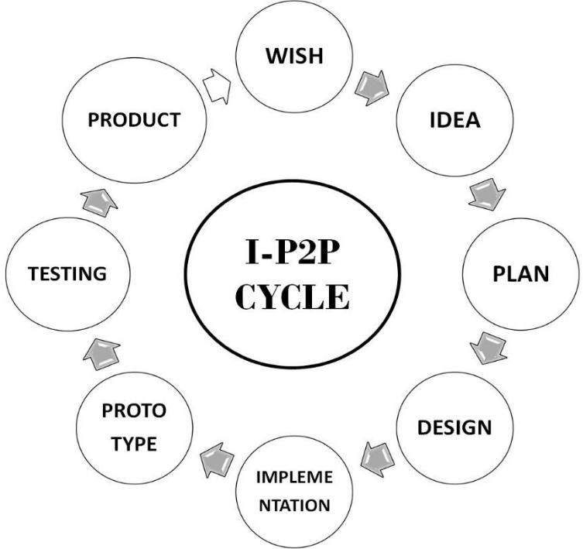

Initial Focus of NIC Plan. The plan focuses on following: –
Engagement of Industry. Initially, most progressive and dynamic firms are engaged to solve their critical industrial problems and sponsor fully funded projects. The firms are engaged by NORIIC.

Tapping of Innovative Brains. Undergraduate students start their academic career with innovative approach right from the start. NUTECH has devised test methods to tap innovative brains in order to explore their potential for innovation. Candidates with innovative ideas, concepts are given opportunity to complete their dream projects.

Innovation Hobby Shops (IHS). Selected students work in their respective departmental innovation hobby shops with the objective to complete their novel project by utilizing all resources available in hobby shop, teaching labs and research labs of NUTECH.

System of Specialized Training. NUTECH students (undergraduate level) are required to study specific subjects particularly designed for the training of innovators, transformation of minds to produce novel products, innovate approach to solve problems, and creation of innovation in skills. These interdisciplinary subjects are critical for engineers and scientists to understand complexities of novel product development.
- Learning Communities Program
- Industry Career Acceleration Program
- Technology Leadership Program
- Technology Research Experience Program

CHAPTER 3
WHAT I HAVE LEARNED

What I Learned from My Internship Projects
Introduction
During my internship, I had the opportunity to work on a diverse set of projects spanning web development, computer vision, machine learning, and automation. This chapter outlines the key lessons learned from each project, detailing the scope, advantages, and pros and cons associated with each area of work.

1. Django (Login Page)
Scope
This project involved creating a login page using Django, a popular web framework. The focus was on building secure authentication mechanisms and handling user input effectively.

Advantages
Security: Learning about authentication mechanisms and secure login practices.
Web Development Skills: Gaining hands-on experience with Django, HTML/CSS, and JavaScript.
User Experience: Understanding the importance of user-friendly interfaces.

Pros and Cons
Pros:
Comprehensive Framework: Django provides robust tools for web development, simplifying backend tasks.
Security Features: Built-in features enhance application security.
Cons:
Complexity: Django can be complex for beginners due to its many features and conventions.
Overhead: May involve more overhead compared to simpler frameworks.

2. Local Chat Bot (With Data Trained Using Django)
Scope
This project involved developing a local chatbot trained with data using Django. The goal was to create an interactive system that can process and respond to user queries.

Advantages
NLP Skills: Enhances understanding of natural language processing and chatbot frameworks.
Customization: Allows for custom training data, improving chatbot performance.
Pros and Cons
Pros:
Interactive System: Provides a hands-on approach to building conversational agents.
Custom Training: Tailors the chatbot to specific needs or domains.
Cons:
Complex Training: Requires careful data preparation and training to achieve good performance.
Resource Intensive: Training models can be resource-intensive and time-consuming.

3. Gesture Hand (Detect Hand Movements, Keyboard, Control Game with Gesture)
Scope
This project focused on detecting hand movements and using gestures to control applications or games.

Advantages
Computer Vision: Deepens understanding of gesture recognition and computer vision techniques.
Interactive Control: Offers an innovative way to interact with applications.
Pros and Cons
Pros:
Novel Interaction: Provides a new form of user interaction through gestures.
Technology Integration: Integrates computer vision with application control.
Cons:
Accuracy: Gesture recognition can be challenging and may require fine-tuning for accuracy.


4. Using Selenium Library (Automatically Book Tickets)
Scope
This project involved automating the ticket booking process using Selenium, a browser automation tool.

Advantages
Automation Skills: Enhances knowledge of browser automation and scripting.
Efficiency: Reduces the time and effort required for repetitive tasks.

Pros and Cons
Pros:
Efficiency: Automates repetitive tasks, saving time and effort.
Flexibility: Can be adapted for various automation needs.
Cons:
Website Changes: Automated scripts may break if websites update their structure.
Ethical Concerns: Automated ticket booking may conflict with site policies.

5. Mark Attendance in Google Sheets Using Gesture
Scope
This project aimed to mark attendance automatically in Google Sheets using gesture recognition.

Advantages
Integration Skills: Teaches integration of gesture recognition with Google Sheets API.
Innovative Solution: Offers a creative approach to attendance management.

Pros and Cons
Pros:
Automated Attendance: Streamlines attendance tracking with minimal manual input.
API Utilization: Leverages Google Sheets API for data management.
Cons:
Gesture Recognition Challenges: May face difficulties with accurate gesture detection.
Complex Setup: Requires integration of multiple technologies.

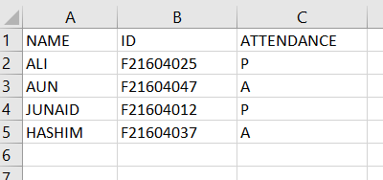

6. Face Detection Automatically Marks Attendance
Scope
This project involved using face detection technology to automatically mark attendance.

Advantages
Facial Recognition Skills: Enhances understanding of facial recognition algorithms.
Automation: Provides an automated solution for attendance tracking.

Pros and Cons
Pros:
Efficient Tracking: Automates attendance marking with minimal human intervention.
Accuracy: Modern facial recognition systems offer high accuracy.
Cons:
Privacy Concerns: Facial recognition can raise privacy issues and ethical concerns.
Implementation Complexity: Requires robust implementation to handle various conditions.

7. Dataset of Image Extract Feature Using the VGG16 Model and Train
Scope
This project focused on using the VGG16 model for feature extraction from images and training a machine learning model.

Advantages
Deep Learning Skills: Provides experience with pre-trained models and feature extraction.
Model Training: Enhances understanding of training and fine-tuning deep learning models.
Pros and Cons
Pros:
Advanced Techniques: Uses advanced deep learning techniques for image processing.
Pre-trained Models: Leverages powerful pre-trained models like VGG16.
Cons:
Computationally Intensive: Training models can be resource-intensive.
Data Dependency: Performance depends on the quality and quantity of training data.

8. CNN + RNN Detect Face and Recognize, Then Compare Both
Scope
This project involved combining Convolutional Neural Networks (CNNs) and Recurrent Neural Networks (RNNs) for face detection and recognition.

Advantages
Hybrid Models: Explores the combination of CNNs and RNNs for improved performance.
Advanced Recognition: Enhances face detection and recognition capabilities.

Pros and Cons
Pros:
Improved Accuracy: Combining CNNs and RNNs can improve recognition accuracy.
Complex Solutions: Provides insights into advanced neural network architectures.
Cons:
Complexity: The hybrid approach can be complex and require extensive tuning.
Resource Needs: May require significant computational resources.

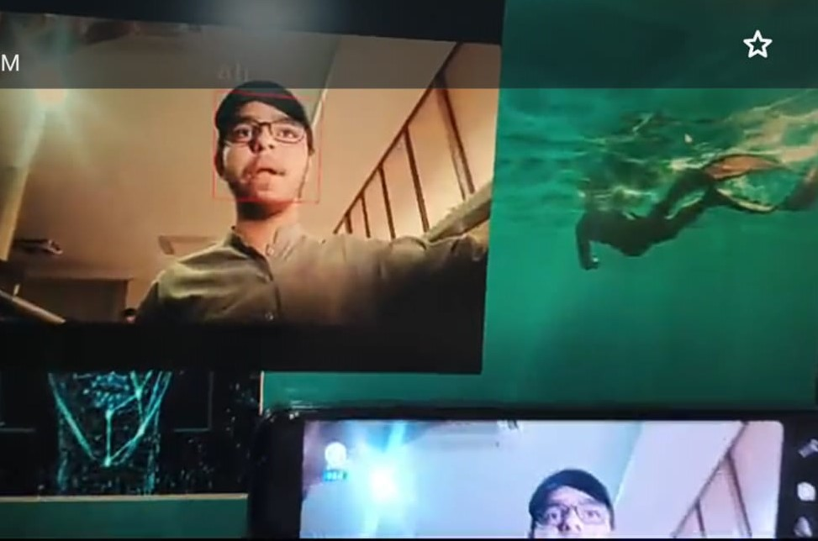

9. Face App (Face Detection with Tkinter)
Scope
This project involved developing a face detection application with a graphical user interface (GUI) using Tkinter.

Advantages
GUI Development: Provides experience with Tkinter for building user-friendly interfaces.
Face Detection Integration: Combines face detection with GUI elements.

Pros and Cons
Pros:
User-Friendly: Allows users to interact with face detection features through a GUI.
Python Integration: Uses Python libraries for both GUI and computer vision.
Cons:
Limited GUI Capabilities: Tkinter is less advanced compared to other GUI frameworks.
Performance: Face detection may be limited by the GUI's performance constraints.

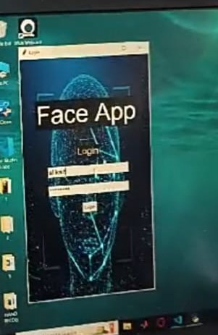

10. Machine Learning Algorithm and Control Your Phone Using Gesture

Scope
This project aimed to control a mobile phone using machine learning algorithms and gesture recognition.

Advantages
Mobile Interaction: Explores innovative ways to interact with mobile devices using gestures.
Machine Learning: Applies machine learning to real-world problems.

Pros and Cons
Pros:
Innovative Control: Provides a novel method of controlling mobile devices.
Cutting-Edge Technology: Uses advanced machine learning techniques.
Cons:
Technical Challenges: Integrating machine learning with mobile devices can be complex.
Gesture Accuracy: Requires accurate gesture recognition for effective control.

Conclusion
The projects undertaken during my internship provided a comprehensive learning experience across various domains of technology. From web development and automation to advanced machine learning and computer vision, each project contributed valuable skills and insights. The combination of these experiences has significantly enhanced my technical expertise and problem-solving abilities.

CHAPTER 4
REFFERENCE & CONCLUSION

CONCLUSION
The completion of this internship marks a significant milestone in my academic and professional journey. Over the course of several months, I had the distinct privilege of engaging in a variety of projects that not only challenged my existing knowledge but also propelled me into new realms of technological understanding and application. Each project presented a unique set of challenges, requiring me to adapt, learn, and apply a broad range of skills and methodologies.

The projects I was involved in were diverse, covering areas such as web development, machine learning, computer vision, and automation. A key project was the development of a secure login page using Django, where I was responsible for ensuring the security and integrity of user data. This project required a deep understanding of web frameworks, secure coding practices, and the principles of user authentication and authorization. Through this, I gained a profound appreciation for the importance of security in web applications, which is critical in today’s digital landscape where data breaches and cyber threats are prevalent.

Another significant project was the implementation of machine learning algorithms for predictive modeling. This involved data preprocessing, feature selection, model training, and evaluation. Working with various machine learning models allowed me to understand the nuances of algorithm selection, hyperparameter tuning, and model evaluation metrics. This experience not only enhanced my technical skills but also provided me with a practical understanding of the entire machine learning pipeline, from data acquisition to model deployment.

In addition, I worked on developing gesture-controlled applications, a project that was both challenging and rewarding. This project required integrating computer vision techniques with real-time processing to interpret and respond to user gestures. It pushed me to explore advanced topics such as image processing, motion tracking, and human-computer interaction. The success of this project underscored the importance of interdisciplinary knowledge, as it required the integration of skills from multiple domains, including software engineering, artificial intelligence, and user experience design.

The key takeaways from this internship are numerous and varied:

Practical Application of Theoretical Knowledge: The opportunity to work on real-world projects provided a practical context to the theoretical knowledge I had acquired during my academic studies. For instance, the process of building a secure login system with Django not only reinforced my understanding of web frameworks but also highlighted the importance of security measures such as encryption, hashing, and secure communication protocols. It became evident that theoretical knowledge, while foundational, needs to be adapted and applied creatively to solve practical problems effectively.

Advanced Technical Skills: Throughout the internship, I was exposed to a wide range of tools and technologies that expanded my technical skill set. For instance, working with Python libraries such as TensorFlow and Keras in the machine learning project deepened my understanding of neural networks and deep learning techniques. Additionally, using Selenium for web automation tasks enhanced my ability to automate repetitive tasks, thus improving efficiency and accuracy. These experiences have made me more versatile and better prepared for the evolving demands of the tech industry, where staying current with new technologies is crucial.

Problem-Solving and Innovation: One of the most significant aspects of this internship was the emphasis on problem-solving and innovation. Projects like the gesture-controlled application required me to think outside the box and develop creative solutions to complex problems. For instance, integrating gesture recognition with real-time response demanded a deep understanding of both the underlying technology and user interaction patterns. This project, in particular, taught me the value of iterative development, where continuous testing and refinement lead to a more polished and effective solution.

Understanding of Professional Workflow: Beyond technical skills, this internship provided valuable insights into the professional workflow. I learned the importance of project management, including setting realistic goals, managing time effectively, and meeting deadlines. Collaboration was another critical aspect, as many projects required teamwork and effective communication with peers and supervisors. This experience has better prepared me for the collaborative nature of professional environments, where teamwork and communication are as important as technical competence.

Adaptability and Continuous Learning: The dynamic nature of the projects I worked on required me to be adaptable and open to continuous learning. Whether it was learning a new library or adapting to changes in project requirements, the ability to quickly grasp new concepts and apply them was crucial. This adaptability is a key takeaway, as the technology field is constantly evolving, and the ability to learn and adapt quickly is essential for long-term success.

In conclusion, this internship has been an invaluable experience that has significantly contributed to my personal and professional growth. It not only enhanced my technical abilities but also provided me with a deeper understanding of the practical applications of my academic knowledge. The skills and experiences gained during this internship have prepared me for future challenges in my career and have instilled in me a confidence that I can contribute meaningfully to any team or project I am a part of.

REFERENCES
- Python Software Foundation. (2023). Python Language Reference, version 3.8. Retrieved from http://www.python.org.
- This source provided comprehensive documentation on Python, a language that was integral to the majority of the projects I worked on during the internship.

- Django Documentation. Django Software Foundation. Retrieved from https://docs.djangoproject.com.
The official Django documentation was a crucial resource for understanding the intricacies of this web framework, particularly in implementing secure web applications.

- Bishop, C. M. (2006). Pattern Recognition and Machine Learning. Springer.
- This textbook offered in-depth theoretical foundations for many of the machine learning algorithms I implemented during the internship.

- Selenium Documentation. SeleniumHQ. Retrievedfrom https://www.selenium.dev/documentation.
Selenium’s documentation was instrumental in automating web browser tasks, which was a key component of one of the automation projects.

- He, K., Zhang, X., Ren, S., & Sun, J. (2016). "Deep Residual Learning for Image Recognition." Proceedings of the IEEE Conference on Computer Vision and Pattern Recognition (CVPR), 2016, pp. 770-778.
This paper provided insights into the implementation of deep learning models, particularly in the development of gesture-controlled applications.

- Goodfellow, I., Bengio, Y., & Courville, A. (2016). Deep Learning. MIT Press.
Goodfellow and his co-authors provided a comprehensive overview of deep learning, which was fundamental to several of the machine learning projects I undertook.

- Geron, A. (2019). Hands-On Machine Learning with Scikit-Learn, Keras, and TensorFlow. 2nd Edition. O'Reilly Media.
This book served as a practical guide to implementing machine learning models, particularly those using Scikit-Learn and TensorFlow, which were extensively used during the internship.

- Rao, K. R., & Yip, P. C. (1990). Discrete Cosine Transform: Algorithms, Advantages, Applications. Academic Press.
The Discrete Cosine Transform (DCT) was explored during the image processing tasks within the computer vision projects, making this book a valuable reference.

- Russell, S. J., & Norvig, P. (2020). Artificial Intelligence: A Modern Approach. 4th Edition. Pearson.
Russell and Norvig’s work provided a strong theoretical foundation in AI, which was applicable across multiple projects during my internship.

